# 01.Snow Showdown

**Environment Specifics**

Please be aware that every JS environment may **behave differently** when executing code. Certain things that work in the browser are not supported in **Node.js**, which is the environment used by **Judge**.

The following actions are **NOT** supported:

* **.forEach()** with **NodeList** (returned by **querySelector()** and **querySelectorAll()**)
* **.forEach()** with **HTMLCollection** (returned by **getElementsByClassName()** and **element.children**)
* Using the **spread-operator** (**...**) to convert a **NodeList** into an array
* **append()** in Judge (use only **appendChild()**)
* **prepend()**
* **replaceWith()**
* **replaceAll()**
* **closest()**
* **replaceChildren()**
* **concat()**
* **at()**
* Always turn the collection into a **JS array** (forEach, forOf, et.)

If you want to perform these operations, you may use **Array.from()** to first convert the collection into an array.

**Use the provided skeleton to solve this problem.**

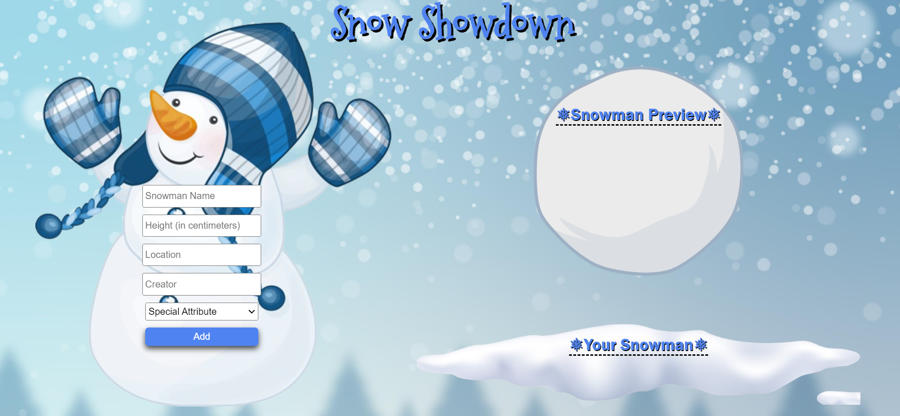**Write the missing functionality** of this user interface. The functionality is divided in the following steps:

**Your Task**

**Write the missing JavaScript code** to make the **Snow Showdown** work as expected:

All fields **(Snowman Name, Height (in centimeters), Location, Creator,** and **Special Attribute)** are **filled with the correct input**

* **Snowman Name, Height (in centimeters), Location, Creator,** and **Special Attribute** are **non**-**empty** **strings**. If any of them is empty, the program should not do anything.

## 1.Getting the information from the form

• When the **["Add"]** button is clicked, the information from the input fields is listed in the "**Snowman Preview**" section. A **list item** is added to the **"snowman-preview "** unordered list.

* The list item should follow the same text format and order as shown in the provided picture.
* When the button is clicked, the **input** fields must be **cleared**, and the **["Add"]** button should be **disabled**. Additionally, the **"Edit"** and **"Next"** buttons need to be added.

The HTML structure looks like this:

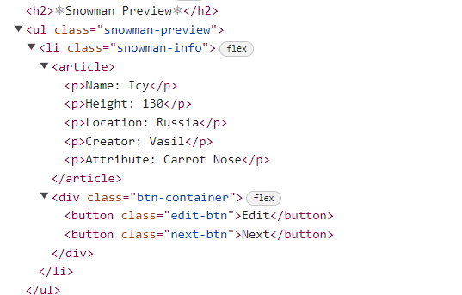

**2.Edit Snowman**

**The functionality here is the following:**

* **When the "**Edit" **button is clicked, all of the information is loaded in to the input fields from step 1 and all the buttons in Snowman Preview section are removed while the** ["Add"] **button is enabled again.**

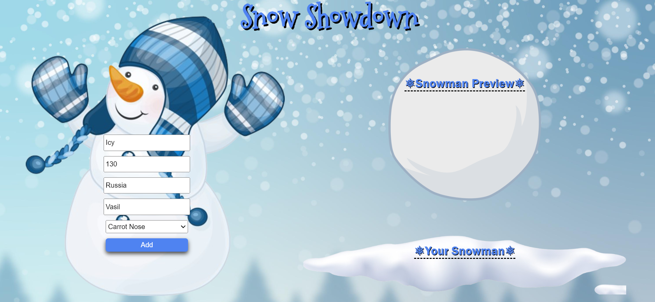

* **The list items must be removed from the** "snowman-preview" 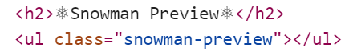

**3.Next**

* **When the** "Next" **button is clicked,** **the information from** "snowman-preview" unordered list must be transferred to "snow-list". **For you, this means removing everything inside of the <ul> with class =** "snowman-preview" **and adding in** "snow-list", **the list item with same information** The "Send" button must be **added.**

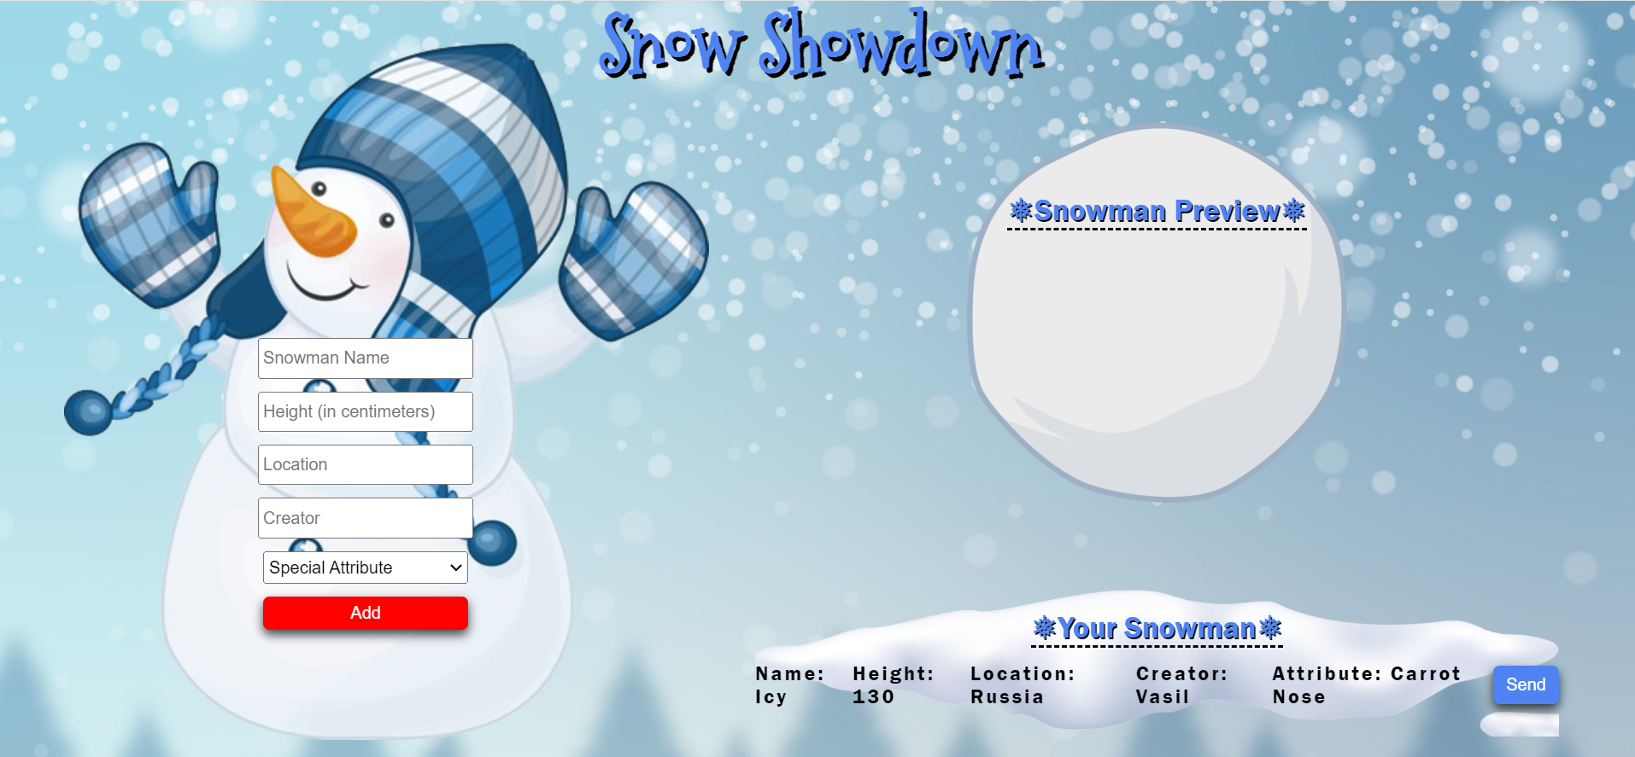

* **This is the HTML** structure **of the** "snow-list" unordered list**:**

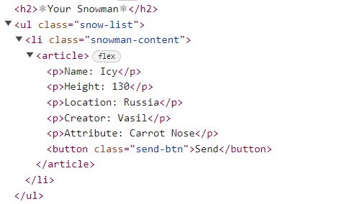

**3.Sending**

* **When the** "Send" **button is clicked,** you must remove **main** element from the HTML structureand then **add** "Back" **button** to the **body** and make **visible** the image with **id "back-img"**

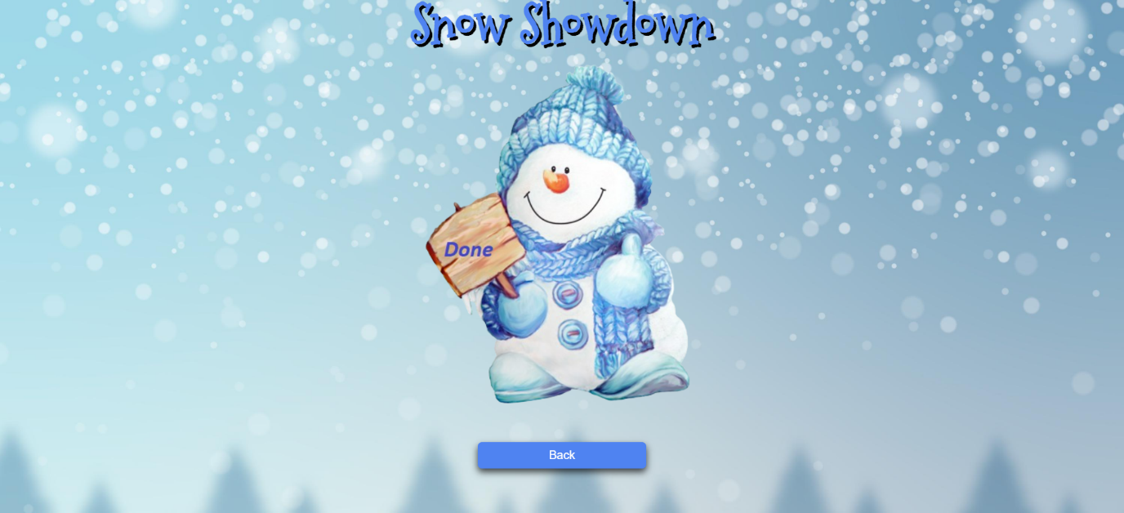

* **This is the HTML** structure **of the** body**:**

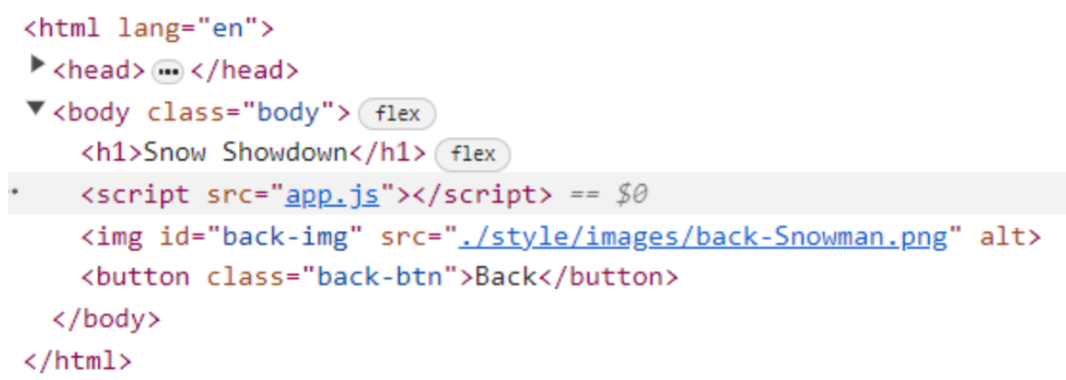

**4.Back**

* **When the** "Back" **button is clicked,** you must **reload** the page.

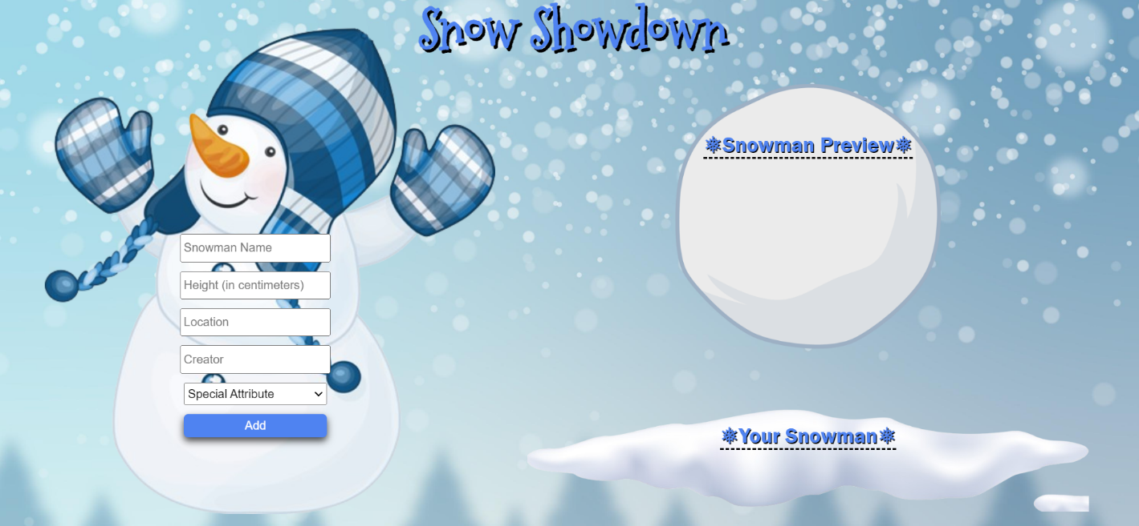

## Submission

Submit only yours **solve()** function.

*GOOD LUCK… ☺*